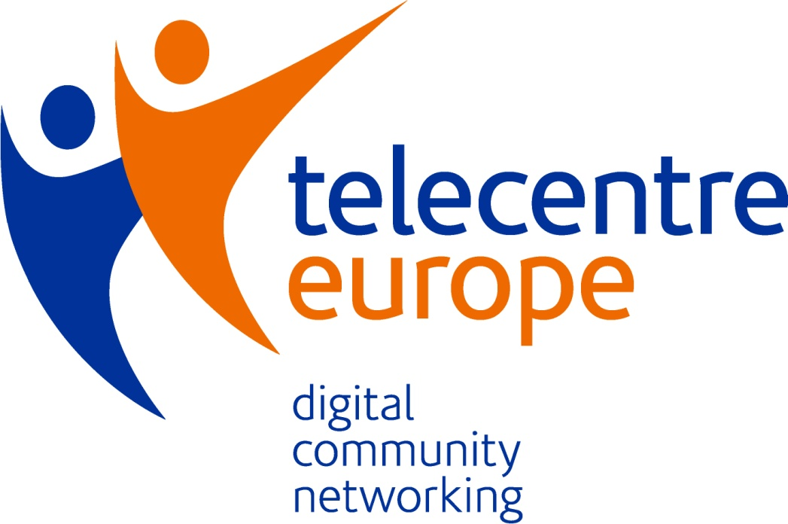

Membership

» terms and conditions

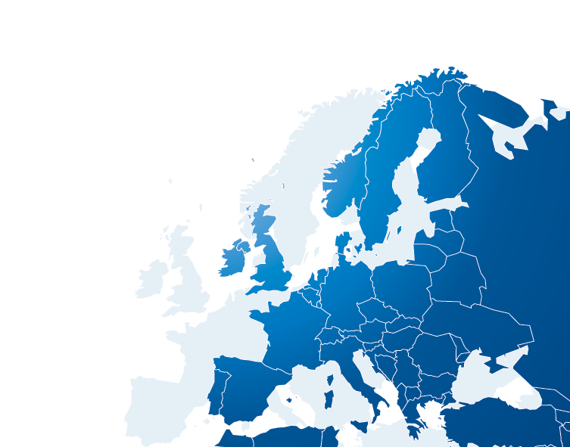

TELECENTRE-EUROPE: GOALS & ACTIVITIES

Main goal
The main goal of Telecentre-Europe AISBL is to increase the impact, effectiveness and profile of its members, and thereby improve the quality of life, employability and social and civic participation of the citizens they serve.

Main activities (Telecentre-Europe Statutes, Article 3.):
The principal activities that Telecentre-Europe AISBL will carry out is as follows:
- Promote the exchange and sharing of resources, skills, competences and knowledge between its members
- Promote and defend the collective interests of its members to institutional and private stakeholders, and policy makers
- Support and inform its members in all matters of an administrative, operational or technical nature
- Respond to European and international calls for projects in the interests of its members
- Organize international events, such as conferences, conventions, seminars, workshops or symposiums related to the scope and goal of the association
- Contract with members for the delivery of projects or activities related to the scope and goal of the association
- Distribute funding for example through the issuing of grants for projects or activities related to the scope and goal of the association
- Commission, undertake, or participate in research related to the scope and goal of the association
- Support the development and the implementation of European, regional or global information society, technology or other societal policies
- Help governments, institutions and agencies to understand the needs of citizens with regards to digital skills and competences
- Hold reserves to carry out actions related to the scope and goal of the association

The Association shall have the right to exercise, alone or in collaboration with third parties, directly or indirectly, all activities related, directly or indirectly, to its purpose not only in Belgium, but also abroad.

MEMBERSHIP

- Membership status

Telecentre-Europe is composed of members and associated members who share the aims and objectives of the association. Each member, except for associated members, has one vote on each resolution or any other decision making process in the General Assembly. Associated members only have an advisory voice.

  - Members
Organizations (NGOs, governmental bodies, social enterprises) geographically located in the European zone whose profiles fit under one or more categories below:
• Individual telecentres that don’t belong to formally established networks of telecentres
• Formally established networks of telecentres
• Organizations running informal networks of telecentres
• Organizations running, supporting or whose work directly impact telecentres
  - Associate members
Any person, association, organisation, institution or company wishing to support the activities of Telecentre-Europe. Associate members can be located within, or outside of the European zone.

- Benefits
  - Networking and knowledge sharing - TE facilitates / acts as a broker for the sharing of products, knowledge and expertise among our members
    - Access to small grants for systematic staff & volunteer exchange scheme
    - Access to TE’s online professional community, newsletter, Facebook, LinkedIn, and all other online networking facilities
    - Subsidised participation at the TE annual conference and GA meetings
  - Advocacy at European level
    - Increased visibility at European level and enhanced credibility at national level through:
- TE promotional materials
- Participation in various relevant events of TE or members (facilitated by TE)
- Members’ profiles on the TE website
- News on national activities on the TE website and in social media channels
- Facilitated participation in European researches and studies relevant to members
    - Access to an inward investment broker service: hardware and software donations, ICT product testing, training & student volunteer placement, funding / grants screening
  - Capacity building
    - Access to training programmes organized by TE or its partners on various topics of interest
    - Access to grants for organizing / developing national activities regarding some European campaigns / projects (e.g. Get online week)
    - Access to European funded projects in consortia built / facilitated by TE
    - Access to award schemes developed by TE for its members within events and campaigns (e.g. TE Awards 2012)

- Responsibilities
  - Telecentre-Europe
    - Provides the Member with access to the community network through online and face-to-face meetings (e.g. annual summit, membership meeting)
    - Provides the Member with access to its online resources, including the online community, resource banks, and social media channels
    - Assures involvement of the Member in its campaigns, events, and projects
    - Provides priority to the Member to access grants, awards, and partnership opportunities
    - Promotes and facilitates knowledge and resource sharing among members
    - Offers the Member to make use of the Telecentre‐Europe brand
    - Conducts advocacy at European level and supports the advocacy efforts of the Member at national or regional level
    - Represents the interest of the Member at various relevant European and global events, and where possible, facilitates the participation of the Member at such events
    - Offers an inward investment broker service: hardware and software donations, ICT product testing, training & student volunteer placement
    - Provides a channel to services/products from stakeholders or partners: libraries, resources, funding & award opportunities screening service
    - Provides the Member with capacity-building consultancy through a ‘buddy brokerage’ or peer assistance
    - Organizes open consultations among members when the Member initiates such discussion
    - Ensures visibility of the Member through its promotional materials, puts its logo and description appearing on its website
    - Promotes news items about activities of the Member to gain visibility and European level branding on its materials, which will enhance the Member’s credibility at national level
    - Invoices members annually for the membership fees
    - Provides members with a welcome package containing membership certificate and information about the membership

  - The Member and the Associate Member
    - Actively participates in the Telecentre-Europe online community (http://www.unite-it.eu/)
    - Actively participates in campaigns, surveys, events, or other initiatives of Telecentre-Europe
    - Provides Telecentre-Europe with basic information and data about its activities, services, number and composition of users on a regular basis
    - Displays Telecentre-Europe logo and makes reference to its membership in Telecentre-Europe on its website
    - Pays the membership fee upon invoice issued by Telecentre-Europe until the deadline indicated on the invoice

  - Membership fee
The Member and the Associate Member pays an annual fee fixed by the General Assembly (GA) on proposal of the Board.
The following membership fee categories and annual membership fees are set by the GA:
Members €300
Associate members €500
After the due date of paying the membership fee, if not paid, Telecentre-Europe sends out a reminder to the Member. The membership status of the Member will be suspended (losing voting rights and all benefits of membership) if the membership fee is not paid within a maximum of 30 days from the date of reminder. The membership status can be renewed after the receipt of the payment.
If the Member fails to pay the membership fee for the year by the end of the year, termination of membership status can be proposed by the Board to the General Assembly.

NOTE: Please see the full text of the Telecentre-Europe AISBL Statutes for all details.

HOW TO JOIN AS A MEMBER?
Organizations interested to join Telecentre-Europe as members have to follow the procedure described below:
- Read carefully all membership related documents sent by email and / or available online in the Membership section of the Telecentre-Europe website
- Complete and submit the online Membership Request Form
An official response will be provided by Telecentre-Europe in a maximum of 10 working days from the date of submission.

